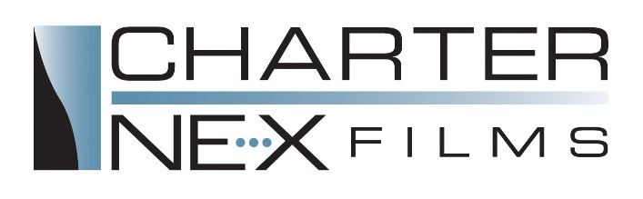
Now Hiring at Charter NEX Films
Extrusion Technician- Start Your Career with Us!

Charter NEX Films is now hiring for Extrusion Technicians in our Milton Plant! Be a part of our Team! Charter NEX Films is the leading independent manufacturer of high performance plastic films. Our films are ideal for markets including: food/beverage, health care, customer goods, pet food, and surface protection.
An employee in this entry level class is responsible for the efficient operation of extrusion equipment to produce high quality polyethylene film. This position is an apprentice role spent in a training capacity on Charter’s computer training program and working closely with experienced operators in line operation. The position reports directly to a Shift Leader with guidance provided by experienced Extrusion Technicians. Other responsibilities include: completing setup/process control to ensure accurate procedures, complete process control documentation, work efficiently on production scheduling computers, and labeling/separating scrap product.
This position has potential for career advancement, and we offer competitive wages and an exceptional benefit package on the first day of work. Candidates must have a high school diploma. We are looking for candidates with excellent multi-tasking skills, enjoy moving and working in a fast paced environment, and exhibits the physical capabilities to effectively and safely perform all aspects of the job in accordance with the physical standards of the position.
This position is full time position consisting of a 12 hour rotational schedule. The shifts run from 7am-7pm and 7pm - 7am. Every 4 weeks, employees flop shifts going from nights to days or vice versa. This allows employees to get full training and experience while having a 3 day weekend every other week. Employees work 7 out of 14 day payroll period.
Benefits include:
- Competitive wages
- Performance based raises
- Quarterly Production Bonus Program
- Full medical, dental, life, and disability insurance on day 1.
- 401k with company match
- Vacation, Sick, and Holiday pay
- Perfect Attendance Quarterly Bonus

Please stop in to fill out an application at our plant at 1264 E. High St Milton, WI 53563 or send in your resume to mamiller@charternex.com. To learn more about our company, visit our website: www.charternex.com

